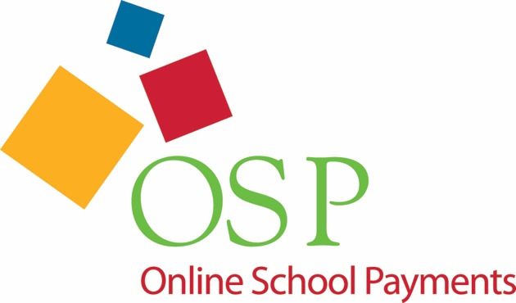
Online payment for school activities
Credit and Debit cards accepted

Are you tired of making an extra trip to school to pay a fee?
Are you tired of sending you kids to school with cash or checks that they misplace?
Would you rather make a payment anytime from the comfort of your own home?
If you answered yes to any of these questions, please visit our new payment site where you can now pay your student’s school fees by debit or credit card online using a web browser from any location, 24 hours a day.
https://osp.osmsinc.com/KnoxTN/
- Log on to the link above and click on “High School”. Choose “Bearden High”.

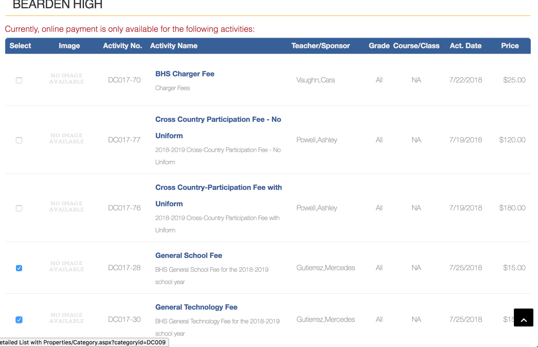
- Next, check the box next to General School Fee ($15) and Technology Fee ($15).

- Click “Add to Cart”, and then choose “Checkout”.
- If you do not already have an account set up, “Create an Account”.
- Once you have your account set up, the site will have you link your student(s) to your account using their student ID number. You can find your students ID number using Parent Portal (Aspen). *You can connect multiple students to your account.
- You should now be able to “checkout”. Please note that there is a service fee to complete online transactions.
The payment will immediately be credited to your student and processed. You will receive a receipt via email.

